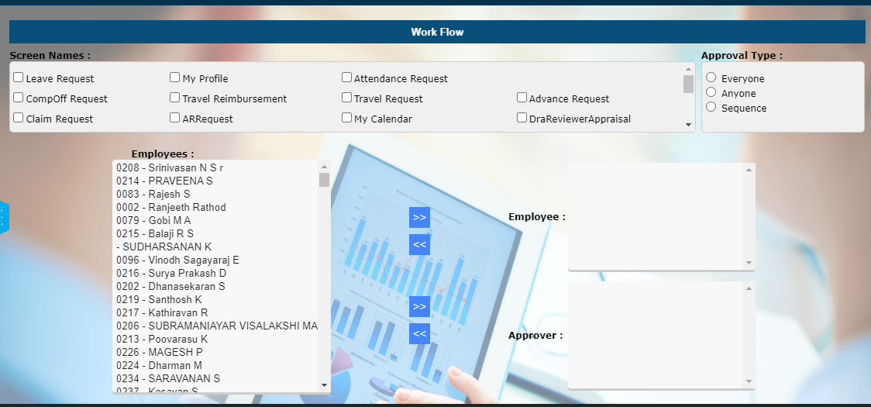

- We Can’t Edit Record
- Duplicate Records to Save
- Can’t Find Employees Wise Unmapped Approval Routing
- Can’t Find the Process or Screen Wise Unmapped Approval Routing Employees list
- Can’t change Approval Type
- Can’t Change Sequence Number for Approval Process
- Can’t Replace Approver Name

